**Oh Try try try try**

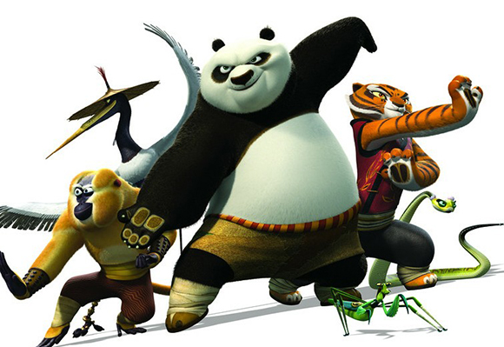

**Try(周杰倫&派偉俊)**

**電影功夫熊貓3全球主題曲**

**不停嘗試吧**

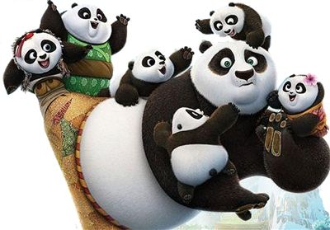

**Just do what is right**

**就去做對的事情**

**You'll fly so high high high high**

**你將展翅高飛**

**Let go of the brakes**

**放輕鬆**

**Be who you are**

**做你自己**

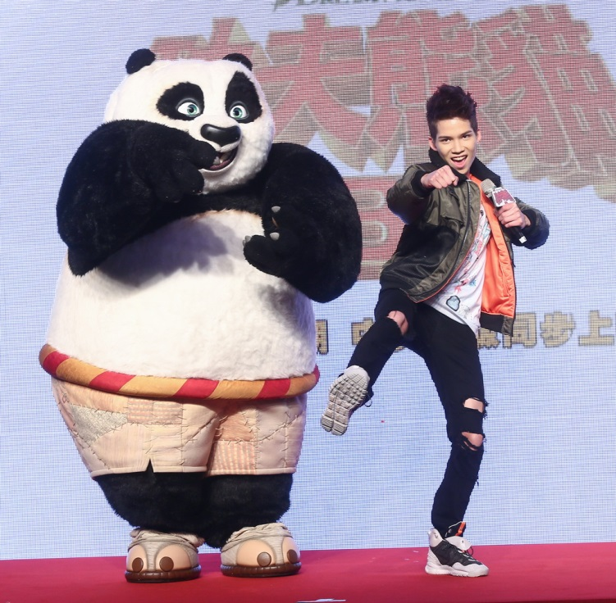

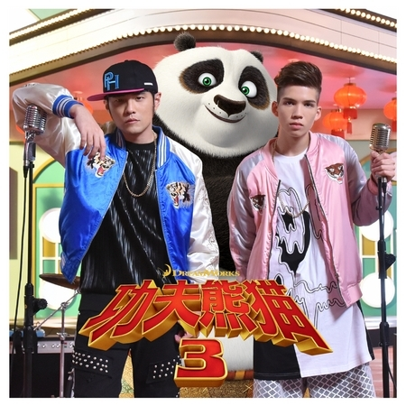

**Be yourself 'cause your power is on**

**你會做自己因為你已找到能量**

**When you believe in what you've got**

**當你相信自己得到什麼**

**You know you're perfect just be who you are**

**你會知道做自己是最完美的**